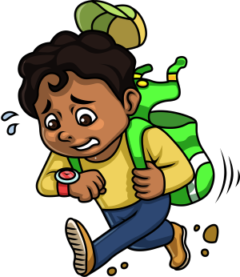Jeremy woke suddenly from a dream. He noticed that the clock on his shelf read 8:47 AM.

*Jeremy was late for school!*

He shot out of bed and raced into the kitchen. Nobody else was up either. Odd. The kitchen table was bare and there were no dirty dishes in the sink.

*Great, Mom must have overslept*, he thought to himself while **devouring** a granola bar. He then poured a half glass of cold milk, chugged it down in four loud gulps, and slammed shut the refrigerator door in a **panic**.

After his rushed breakfast, Jeremy returned to his bedroom, food and drink smeared across his face, and looked for something to wear. He swiftly grabbed a wrinkled shirt and a pair of old jeans and put them on, paying no mind to his **appearance**.

He **glanced** over at his clock. It was now 9:06 AM. The sun had long since **breached** the horizon and now shone brightly through his bedroom window. Jeremy was never late. *Ever.* He has always turned in his assignments on time and typically arrived at class long before his friends.

The more he thought about this, the faster his blood pulsed. He noticed that his breathing had sped up and so closed his eyes, trying to take a moment to calm down.

No luck.

As he slammed his feet down into his shoes, not even bothering to tie them, Jeremy realized that his mother would need a little time to get ready

before she drove him to school. So, he dashed up the staircase to wake her, his panic growing.

“Mom!” he whispered loudly, not even bothering to knock on her door.

“Mom, wake up!” he **demanded**, this time a little louder.

Jeremy’s mother rolled over and half opened her eyes. She peered at him, half asleep, and asked, “What are you doing up so early? Go back to bed.”

Jeremy let out a loud sigh. “Mom, it’s after 9:00, and I missed the bus, “he barked. “You didn’t get me up!”

Lazily, his mother sat halfway up and looked over at her own clock.

“Come on!” Jeremy pleaded. “You’ve got to hurry!”

But his mother only chuckled. She then let out her own sigh through a wry smirk.

“Seriously, Jeremy. Go back to bed.” She then laid back down and mumbled loudly into her pillow. “It’s Saturday.”



**Devour: *to eat quickly***

**Panic: *a sudden feeling of fear***

**Appearance: *the way that something looks***

**Glance: *a quick look at something***

**Breach: *to make a gap or break through***

**Demand: *a request made as a command***